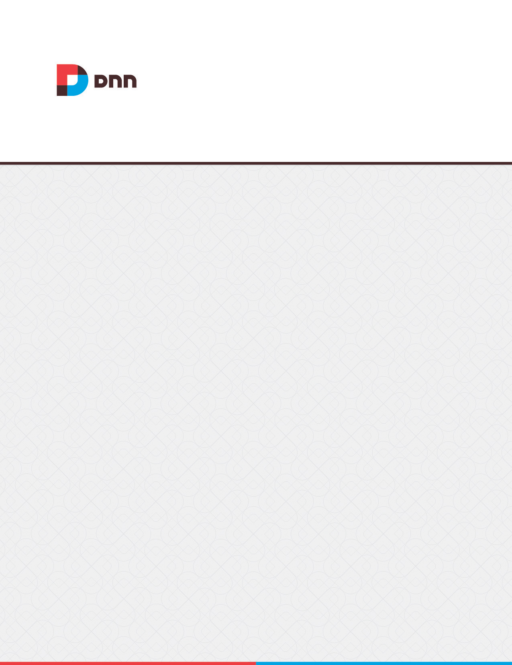

**Survey 04.70.00**

**User Manual**

Contents

Survey 3

Adding a Question 4

Managing Questions 5

Configuring the Survey 5

Clearing Survey Results 7

Exporting Survey Results 7

# Survey

Survey displays a survey consisting of one or more survey questions. Questions can have either a single or multiple choice answers. One answer to a question can be selected as the correct response, thereby enabling the survey to function as a quiz. Authorized users can submit their response to the survey and/or can view current survey results. Access to view the accumulative results can be restricted allowing businesses to collect data, feedback or run competitions. The Survey uses cookies to remember which computers have already submitted a response to the survey, reducing the likelihood of an individual to answer the survey repeatedly. Optional features include the ability to set a closing date for submitting responses to the survey, and the ability to set the width of the results graph. Users must be granted Edit Module permissions to add, edit and delete survey questions.

Survey can be downloaded from [CodePlex](http://dnnsurvey.codeplex.com/) and must be deployed and installed by a Super User.

Module Version: 04.70.00 / Minimum DNN Version: 05.06.02

Features: ISearchable

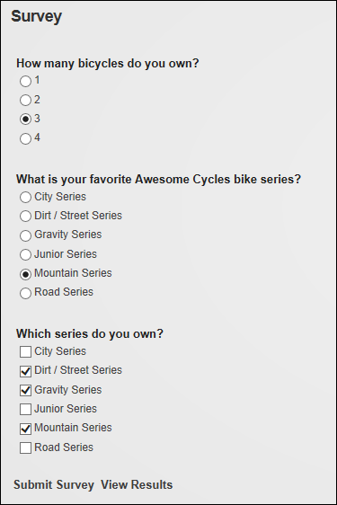  
The Survey

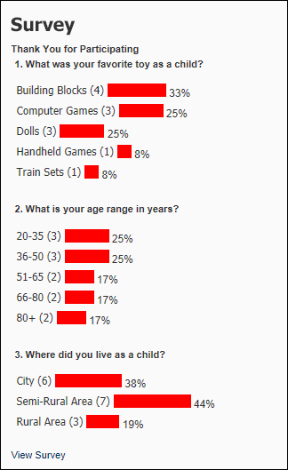  
Survey Results

# Adding a Question

Module editors can add single selection questions that permit users to select one answer only or multiple selection questions that permit multiple answers. Each answer can then be added as an option and ordered according to how they will appear on the page. One or more options can be marked as the correct answer or no options can be selected if the correct answer isn't shown, known or if the question forms part of a survey. Note: A question may have multiple correct answers.

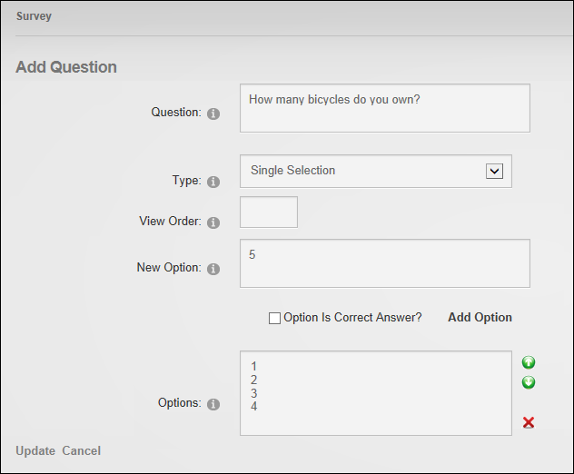  
Adding a Survey Question

# Managing Questions

Module editors can edit the text of a survey question, however the associated options cannot be edited therefore they must be deleted and new options added. Questions and their associated options can be deleted.

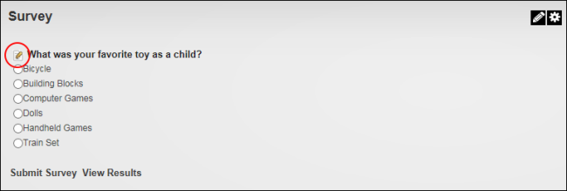

# Configuring the Survey

Administrators can configure the survey settings to add a closing date, determine who can view survey results and choose to track vote using cookies or one vote per user. If cookies are selected then voting is restricted to one vote per computer. Each computer can only submit results once, unless the cookie is deleted. This option doesn't require users to login to vote. Alternatively one vote per user restricts voting to one per registered user and requires users to be logged in to vote. The look of the survey can also be modified by setting the maximum bar graph width of survey results. For example, if the width is set to 200 pixels then the maximum width of the graph bar will be 200 pixels for a 100% response. The default width of the survey bar graph is 100% of the module width.

Here is a list of the replacement tokens that can be added to the survey results template:

|  |  |
| --- | --- |
| Token | Description |
| [SURVEY_OPTION_NAME] | Displays the name of each option. |
| [SURVEY_OPTION_VOTES] | Displays the total number of votes for this option. |
| SURVEY_OPTION_IMAGEPATH] | Sets the image path to the survey bar graphic |
| [SURVEY_OPTION_GRAPH_WIDTH] | Enables the 'Maximum Bar Graph Width' setting |

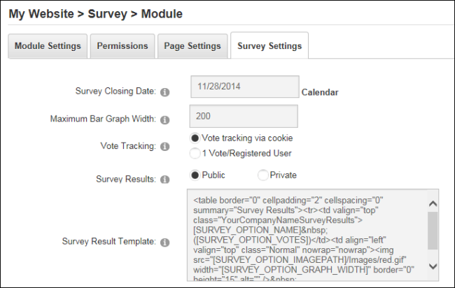  
Configuring the Survey

# Clearing Survey Results

Administrators can clear all existing votes to restart a survey by modifying Survey Settings.

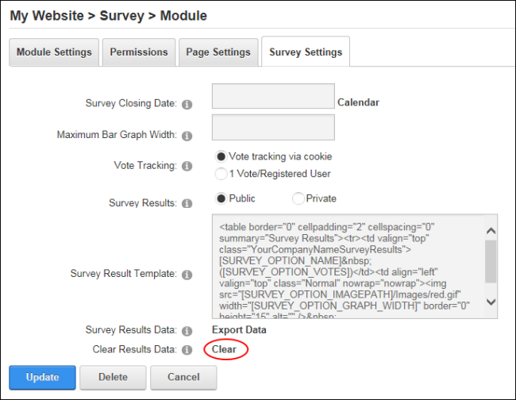  
Clearing Survey Results

# Exporting Survey Results

Administrators and page editors can export the votes submitted by registered users on the Survey Settings page. Results are saved as a csv (comma separated values) file.

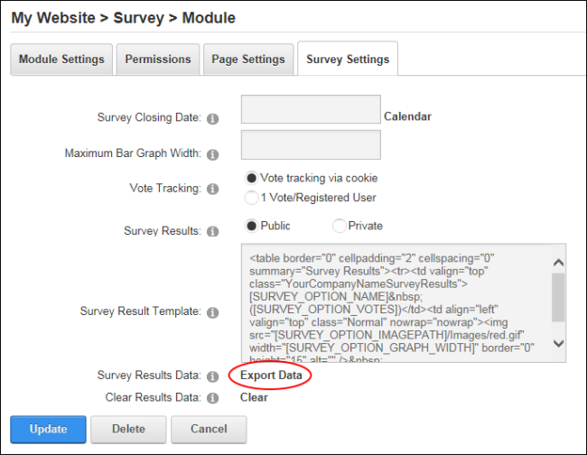 Exporting Survey Results